亞洲大學碩士班暨碩士在職專班論文時程表
Schedule of Theses for Master Programs & On-job Master Programs in Asia University

項次  Item | 申請項目  Application Item | 申請時程  Application Schedule | 應備表單及資料  Forms and Data to be Prepared | 研究生注意事項  93.04.12製表  Notice for Graduate Student
一 | 申報指導教授  Report the advisor | 依各系所規定辦理  Process this according to the institute’s regulations | 指導教授同意書  Advisor Consent Form | 至「學生資訊系統」完成申請  Apply online from Student Information System
二 | 變更指導教授申請  Apply for changing the advisor | 依各系所規定辦理  Process this according to the institute’s regulations | 1.變更指導教授申請表  1. Application Form for Changing the Advisor  2.新指導教授之同意書  2. New advisor’s Consent Form | 至「學生資訊系統」完成申請  Apply online from Student Information System
三 | 變更論文題目申請  Apply for changing the thesis topic | 依各系所規定辦理  Process this according to the institute’s regulations | 變更論文題目申請表Application Form for Changing the Thesis Topic | 向各系所辦理  Process this in the institute
四 | 論文考試申請  Apply for Degree Exam | 1.本學期預計可完成該系所規定所有應修課程  1. All the required courses stipulated by the institute are expected to be finished in this semester.  2.上學期於12/31前提出申請，下學期於6/30前提出申請  2. In first semester, the application should be made before Dec. 31. In second semester, the application should be made before Jun. 30.  3.論文口試依各系所規定，向該系所提出申請  3. The application for oral defense should be made to the institute, according to the institute’s regulations. | 1.學位考試時間申請表  1. Application Form for Degree Exam Schedule  2.完稿論文乙本  2. One copy of the finished thesis script | 1.備齊資料向各所申請進行論文口試  1. Prepare all the data to apply for oral defense in the institute  2.各系所如另有碩士學位考核規定，必須先通過該項規定。  2. If the institute has other master degree assessment regulations, the student should pass the regulations first.  3.論文考試須在本校舉行  3. The Degree Exam must be held within our school.
五 | 論文考試  Degree Exam | 1.各所承辦人請先彙集口試資料，將口試委員資料表、聘書簽呈送校長核准（先會註冊組），秘書室蓋學校章即可發聘。  1. The undertaker in the institute should collect the dada about oral defense first, to present the Oral Defense Commissioner Information Form and the Appointment Petition to the president (notify the Registry Section first). The appointment can be issued after the Secretariat Office has stamped the school’s official seal on it.  2.請依口試委員名單，事先向會計室預支口試費與車馬費，  於當日口試完成後，請口試委員簽收，再歸墊預支款。  2. Please draw the oral defense fee and the transportation allowance from Accounting Office in advance, according to the name list of the oral defense commissioners. On that day when the oral defense is over, the commissioners should sign their names after receiving these. Then, return the remaining prepaid money.  3.論文考試完畢當天，由論文考試召集人繳交成績到該所，該所承辦人輸入題目及成績，再以書面送到教務處註冊組備查。  3. On that day when the Degree Exam is over, the exam convener should submit the scores to the institute. The undertaker in the institute should input the topic and the scores, and send the written data to the Registry Section at Academic Affairs Division for reference. | 1.口試費一覽表  1. List of Oral Defense Fees  2.論文口試總評表  2. General Comments Form for Oral Defense  3.論文口試評分表  3. Oral Defense Grading Form  4.考試費印領單據  4. Exam Fee Printed Receipt | 1.成績以出席委員評分平均計算，評分並以一次為限；論文口試以70分為及格，重考以一次為限（二次不及格應令退學）。  1. The score is calculated according to the average of the scores given by the attending commissioners. The score will be given once. The qualified score in oral defense is 70. The re-exam will take place once only (Anyone who fails twice will be dropped out).  2.成績須密封，請考試召集人於口試當日送各所辦公室。  2. The scores should be sealed up, which will be sent by the exam convener to the institute’s office on that day when the oral defense is over.
六 | 辦理離校手續  Process the procedures for leaving school  論文摘要線上建檔  File the thesis abstract online  繳交論文  Submit the thesis | 離校手續完成 領取學位證書時間  Complete the procedures for leaving school Time for receiving the diploma | 1.論文摘要線上建檔完成  1. Complete the online filing of the thesis abstract  2.論文格式審查表（各所自定）  2. Thesis Format Review Form (set up by the institute)  3.精裝﹑平裝論文數本  3.Several hardcover and paperback copies of the thesis | 1.論文繳交冊數 圖書館：二本平裝論文  該系所：二本平裝論文  1. The volumes of the thesis submitted:  Library: Two paperback copies of the thesis  The institute: Two paperback copies of the thesis  2.離校流程另行訂定公告之，流程單需繳交教務處方視為  離校手續完成。  2. The procedure for leaving school will be enacted and announced otherwise. The procedure for leaving school will not be completed until the Procedure Sheets have been submitted to the Academic Affairs Division.
六 |  | 請依本校註冊組每學期所發，學生離校程序與學位證書領取規定辦理。可個人或全班由同學代為辦理離校手續。  Please process this according to the procedure for leaving school and the stipulations for receiving diploma, issued by our school’s Registry Section in every semester. A student can be on behalf of another person or the whole class to process the procedure for leaving school.

亞洲大學 外國語文學系碩士班論文口試時程表

時間 | 申請項目 | 申請事項 | 應備表單及資料 | 研究生注意事項
論文口試  1個月前 | 論文考試申請 | 1.應完成入學年度課程規劃課程，包括校定必修課程、系定必修課程及系定選修課程，及補修入學時告知應下修大學部之先修課程。  2.通過論文計畫書審查，三個月﹝含﹞以上)，且其碩士論文經指導教授核可及系主任同意後，始得申請碩士學位考試。  3.完成本系對碩士學位考試有關的修課規定。 | 1.研究生學位考試申請表  (本申請表經由系所及教務處簽核通過後，始能申請學位考試時間)  2碩士班暨碩士在職專班學位考試時間申請表 | 1.備齊資料向系所申請進行論文口試  2.論文考試須在本校舉行
口試3週前 | 口試費申請 | 依口試委員名單，口試費與車馬費，於當日口試完成後，請口試委員簽收，再進行核銷。 | - 研究生學位考試委員戶籍資料表  （參考口試費發給標準）  - 口試費一覽表 | 口試費一覽表、不確定費用者請洽系辦
口試2週前 | 繳交論文初稿 |  | 論文初稿（請參考系網公告格式） | 於口試2個星期前，自行送達口試委員
 | 論文考試 | 論文考試完畢當天，由論文考試召集人繳交成績到該所，該所主辦人輸入題目及成績，再以書面送到教務處註冊組備查。 | 1.論文口試公告  （請口試學生於一週前製作完成並公告）  2.論文口試評分表（每位委員1份）  3.論文口試總評表（1份）  4.論文核定書  5.考試費印領單據（每位委員1份） | 1.成績以出席委員評分平均計算，評分並以一次為限；論文口試以70分為及格，重考以一次為限（二次不及格應令退學）。  2.成績須密封，請考試召集人於口試當日送各所辦公室。  3.論文口試結束後，請到系辦申請碩博士論文上傳帳號密碼，並自行上網更新博碩士論文系統的基本資料。  4.論文格式規定請務必參考系網公告：  系網→表單下載→碩士班表單下載→論文格式規定
口試後1週內 | 繳交完稿論文及線上摘要建檔 | - 於論文口試通過後，繳交完稿之論文。  - 論文摘要線上建檔完成。 | 論文授權書  （請參考系網公告格式及圖書館相關說明）  ps:每份完稿之論文都要附「論文核定書」、「論文授權書」影本。 | - 圖書館：2本平裝論文  - 系辦：2本平裝論文  - 口試委員：每人1本平裝論文
 | 辦理離校手續 | 離校手續完成 領取學位證書時間 | 離校程序-學生資訊系統確認  （每年均可能有更新流程） | 離校程序-學生資訊系統確認。
 | 辦理離校手續 | 請依本校註冊組每學期所發，學生離校程序與學位證書領取規定辦理。可個人或全班由同學代為辦理離校手續。 | 離校程序-學生資訊系統確認  （每年均可能有更新流程） | 離校程序-學生資訊系統確認。

亞洲大學外國語文學系碩 士 班
Asia University Department of Foreign Language and Literature Master Program Degree
研究生論文指導教授申請表
Application Form for Advisor
研究生姓名：  Student Name : | 所屬系所：  Department:
學號：  Student ID: | 入學年月： 年 月  Period of attendance at school: Y M
論文題目：(暫訂)
Thesis/Dissertation Title : ( tentative)

申請日期： 年 月 日
Application Date: Y M D
指導教授： (簽章) 年 月 日
Advisor: (signature) Y M D
系所主管： (簽章) 年 月 日
Department signature: (signature) Y M D
備註：
- 教師指導碩士班學生撰寫畢業論文以學術專長為考量依據，並且指導該系所每一年級學生以不超過三人為原則。
- 本表格應於指導教授簽章後繳回各系辦公室，並經系所主任簽章後備查。

附表一
Attached list 1

亞洲大學 學年度第 學期
Asia University, school year, semester
碩士學位論文研究計畫書審查申請表暨結果
(含作品、成就證明連同書面報告、技術報告或專業實務報告)
Application Form and Results of Master Degree Thesis Research Project Review
(Including: works, achievement proof, reports in papers, technical reports, or professional practice reports)
系(所)別  Department |  | 申請日期  Application  Date | YY / MM / DD
班別  Degree | □碩士班Master Program  □碩士在職專班In-service master program
研究生姓名  Student Name |  | 學號  Student ID
論文題目  Thesis Title | (CH)  (EN)
指導教授  簽章  Advisor signature | 本論文題目與學系專業領域相符:  是  否 (請勾選)
說明(Explanation)：
- 學位論文研究計劃書書面審查通過屆滿兩個月後始得舉行學位考試。
- The degree examination can be held two months after Master Degree Thesis Research Project Review has been approved.
- 審查方式以書面審查為主。
- The method of review will be mainly focused on document review in papers.
- 系(所)應成立「論文研究計畫書書面審查委員會」，審查委員由各系(所)指派至少兩位助理教授級以上教師擔任之。
- The department shall establish a “Master Thesis Research Project Paper Review Committee”. Each department shall assign at
least two professor of assistant level or higher to be the Review Committee members.

- 碩士生於本單上表填妥後，需檢附學位論文研究計畫書提要送至系(所)辦公室，以利安排書面審查相關事宜。
- After completely filling out the form on this sheet, a student shall enclose the paper(s) of the Master Degree Thesis Research Project and send it to the office of the department in order to arrange the related matters of document review.

審查時間  Review Date | YY / MM / DD : - :
審查方式  Method of review | □書面審查Document review in papers  □口試審查Interview/Oral Examination
審查結果  Review results | □通過，可依原題目及計畫進行  Pass. The original title and plan of this research can continue.  □通過，須參酌評審意見修正題目及計畫後進行  Pass. The title and plan of this research must be modified using the comments of the Review Committee.  □不通過，重擬研究題目及計畫後，另行安排審查  Fail. After reconstructing the title and plan of this research, the student should arrange a separate review of the research.
審查委員
簽章
Signatures of the Review Committee
系(所)主任
簽章
Signature of the Department
Chairperson
(正本由系辦公室存查，學生可自行影印留存)
(The original text will be kept by the Department.
The student may keep a copy of this form.)

附表三
Attached list 3
亞洲大學 學年度第 學期
Asia University, school year, semester
研究生學位考試申請表
Application Form of Graduate Degree Examination
研究生姓名  Student Name |  |  |  |  |  |  | 學號  Student ID
系(所)別/  學位學程  department |  |  |  |  |  |  | 班別  Degree |  | □碩士班  Master Program  □碩士在職專班  In-service master program  □博士班  Ph.D. Program
口試日期/時間  Oral Test |  |  | 年 月 日 午 時 分至 時 分  Date/ Time of Day |  |  |  |  |  | 口試地點  Oral Test Location |  | 本校 大樓 室  Building/ Classroom
論文題目  Thesis/Dissertation Title |  |  | (中)  (CH)  (英)  (EN)
學學位考試委員 | 姓名  Name |  | 職稱  Career Titles |  | 服務單位  Service Unit |  | 詳細地址及電話  Address and phone number |  |  |  |  | 證書字號  Certificate Number
學學位考試委員 | (指導教授）
系所審核/簽核
□本系(所)規定修畢學分________學分，申請人本學期尚有必修 學分；選修 學分。
The department (institution) requires credits to exchange____ credits, and have applicants still have compulsory credits for this semester and elective credits
□申請人符合本系(所)有關博、碩士及碩專班研究生修業規定
The applicant meets the requirements of this Department / Institute for the regulations of post-graduate studies of Ph.D., Master or In-service master degree.
□附表一碩士學位論文研究計畫書審查申請表暨結果(請檢附影本；博士班免檢附)
Attach table 1 application form and results of the review of master’s thesis research plan (please attach a copy; the doctoral program is exempt from inspection)
□歷年成績單一份A copy of school transcripts of past years;
□學位論文學術倫理暨原創性聲明書（檢附論文初稿及經指導教授簽名之原創性比對系統檢測結果截圖畫面)
Statement of Academic Ethics and Originality Comparison (Please enclose first draft of paper and original report signed by advisor)
□系所比對報告標準： %(請檢附相關會議資料)
The department comparison report check: % (Please enclose relevant meeting materials)
□學術倫理課程6小時證明書(109學年度（含）起入學之學生需檢附)
Certificate of 6 hours of academic research ethics courses the above information must be attached for (109).
□其他_________________(如各系有其他審查資料請自行增列)
If other review materials will be required, please list them by the Department’s self)
申請人簽章  Applicant signature |  |  |  | 指導教授  Advisor |  |  |  | 系所審核  Department signature |  | 系主任簽章  Department Chairperson signature
年 月 日  YY / MM / DD |  |  |  | □論文原創性比對結果______%  The results of the Turnitin originality check system
教教務處簽核 | 註冊與課務組承辦人審核  Staff Review of  Registration and Curriculum Section |  |  |  |  | 註冊與課務組組長  Section Chief of  Registration and Curriculum Section |  |  | 教務長  President for  Academic Affairs
教教務處簽核 | □指導教授確認及指導人數查核  Check the number of advisees  □歷年成績單一份  A copy of transcripts of past years  □學位論文學術倫理暨原創性聲明書(檢附論文初稿及原創性比對系統檢測結果截圖畫面)  Statement of Academic Ethics and Originality Comparison(Please enclose first draft of the thesis/dissertation and screenshots of detection results of the Turnitin originality check system)  □附表一碩士學位論文研究計畫書審查申請表暨結果(請檢附影本；博士班免檢附)  Attach table 1 application form and results of the review of master’s thesis research plan (please attach a copy; the doctoral program is exempt from inspection)  □學術倫理課程6小時證明書  Certificate of 6 hours of academic research ethics courses
備註  Remark  全文完 |  | 需繳至教務處資料:本表單、附表一、歷年成績單、論文初稿(無須膠裝)、原創性比對系統檢測結果截圖畫面。  Materials to be submitted to the Academic Affairs Office: this form, must attach; table 1, past transcripts, first the draft of the paper (no glue binding), statement of Academic Ethics and Originality Comparison, screenshots of the original system results and Certificate of 6 hours of academic research ethics courses.


亞洲大學
學位論文學術倫理暨原創性聲明書

- 本人 ○○○ （就讀○○學系碩士/碩專/博士班，學號：11XXXXXXX）撰寫之學位論文經自我檢核後確認無違反學術倫理情事，論文倘有造假、變造、抄襲、由他人代寫，或涉其他一切有違著作權及學術倫理之情事，及衍生相關民、刑事責任，概由本人負責，概無異議。
- 學位論文已確實經本校論文內容相似度比對系統檢核，比對結果相似度為
%（檢附論文初稿及原創性比對系統檢測結果截圖畫面），符合系、所、學位學程自訂標準。

聲明人：
中華民國 年 月 日

指導教授簽章：
共同指導教授簽章（無免）：
系所（學位學程）主管簽章：

備註：自111學年度起，研究生應將本聲明書送交指導教授及系、所、學位學程主管簽章，本聲明書正本由各系、所、學位學程留存備查。

Asia University
Statement of Academic Ethics and Originality Comparison

1. As the author of this thesis/dissertation, I（Name：___________________，Student ID number：___________________，Department：___________________）adhere to the principles of academic ethics. I confirm that I have checked my thesis/dissertation and there is no violation of academic ethics. I will be responsible for any falsification, alteration, plagiarism, thesis or dissertation written by someone else , or any other violation of copyright and academic ethics, as well as any related civil or criminal liability.
2. I confirm that I have submitted my thesis/dissertation to the originality comparison system of the university and receive a similarity score of __________%(Enclose first draft of paper and original report signed by advisor), which is in accordance with the standard set by the respective department, graduate institute, or degree program.
Student Name (Please Print Clearly):
____________________________________________________
Student Number:_______________________
Date: _______Y______M_____ D

Signature of Advisor of Thesis/Dissertation:_________________________________
Signature of Co-advisor of Thesis/Dissertation (if any):________________________
Signature of Chair of the Department or Degree program:_______________________

Note: From the fall semester of the academic year 2022, students must submit the statement of academic ethics and originality comparison with the signature of the advisor(s) and the chair of the department or degree program to the department for future reference.

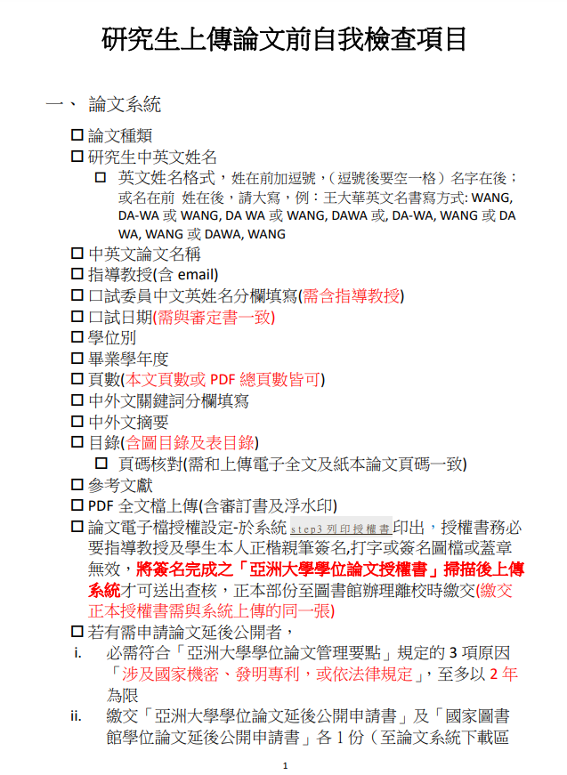

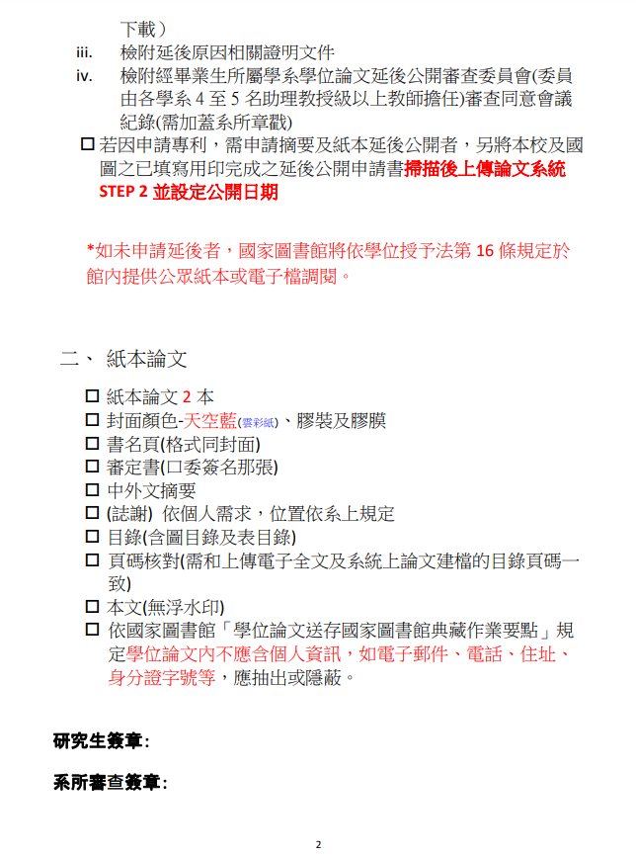

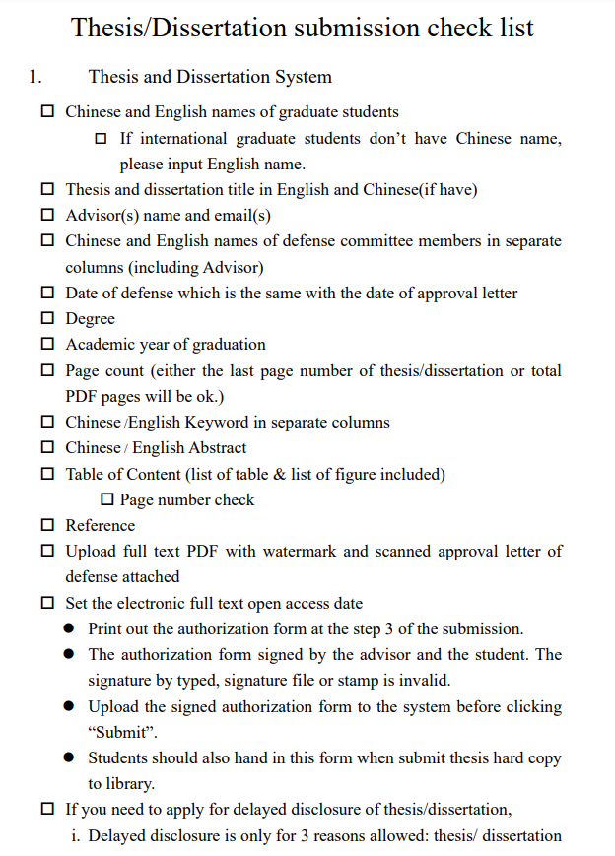

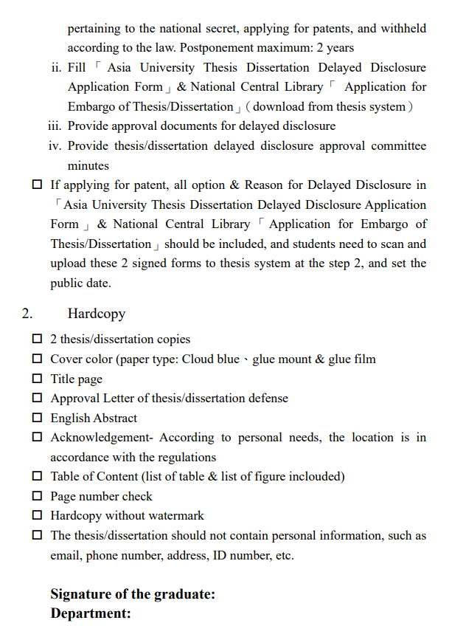

亞洲大學
Asia University
研究生學位考試委員戶籍資料表
Graduate Degree Exam Commissioner’s Household Records Form
系所別  Institute |  | 研究生  Graduate Student |  | 學 號  Student Number
考試委員  Exam Commissioner |  | 身份證  字 號  ID Number
詳 細
戶籍地址
Detailed Permanent Address
電 話
TEL
銀行名稱  Bank | 銀行 分行 【限本人戶名帳號】
銀行帳號  Account number | 【必填】
備 註  Remarks | ※提供非國泰世華銀行帳戶者，匯款需自行負擔匯款手續費。
亞洲大學研究生學位考試費印領單據
Asia University Graduate Degree Exam Fee Printed Receipt
項 目  Item |  | 金 額  Amount of Money |  | 簽 章  Signature
指導教授指導費
Advisor Fee
論文考試費
Thesis/Dissertation Exam Fee
考試委員交通費
Exam Commissioner Transportation Fee
合 計
Total
注意事項：1.每位考試委員，須各填寫一張（請詳填）。
2.論文相關考試費用。請研究生逕至系所詢問。
3.考試結束後，請立即將此表於交回各系所。
Notice: 1. Each exam commissioner should fill out one form (Please fill out in detail).
2. As for the fees related to Degree Exam, the graduate student should ask the institute by himself/herself.
3. After the exam is over, please return this form to the institute immediately.

亞洲大學
研究生學位考試口試費發給標準

項目 | 金 額
論文指導費（限每位研究生，如係共同指導，則平分此筆指導費） | 碩士生3000元
論文指導費（限每位研究生，如係共同指導，則平分此筆指導費） | 博士生5000元
論文口試委員費(碩士論文3名註三、博士論文5名，如係共同指導，則平分此筆口試費) | 每名1000 元
校外口試委員交通費
□汽車、火車、捷運等─覈實報支
□自用汽（機）車─按同路段公民營客運汽車最高等級之票價報支
□飛機、高鐵、船舶─檢據覈實報支

註：1.論文指導費核給標準係依據「亞洲大學教師授課時數暨鐘點費核計要點」。
2.校外考試委員交通費係依考試日期申請，每位考試委員每一考試日期僅發給一份交通費，校外指導教授亦發給交通費，而本校專任教師擔任口試委員無交通費。
3.如校外共同指導教授亦參加口試，得放寬為四人（論文口試委員費）。
亞洲大學 學年度第 學期碩士班研究生學位考試評分表
Degree Exam Grading Form for Graduate Student of Master Program or On-job Master Program, ________Semester in the Year of________, Asia University
系所別  Institute |  | 研 究 生  Graduate Student |  |  |  | 學 號  Student Number
論文題目
Thesis Topic
項目  Item | 評語Comments |  |  | 得分Score | 備註Remarks |  | - 學位考試成績評分以七十分為及格，一百分為滿分。考試成績以出席委員評定分數平均決定之。  1. As for the score in the Degree Exam, the qualified score is 70, and the perfect score is 100. The score will be determined by the average score of the scores graded by the attending commissioners.  - 學位考試成績評定，博士班須有三分之一以上委員、碩士班須有二分之一以上委員評定為不及格者，以不及格論。評定以一次為限。  2. As for the score in the Degree Exam, a disqualified score will be determined, if it is graded to be disqualified by more than 1/3 of the commissioners in a Doctoral Degree Exam or by more than 1/2 of the commissioners in a Master Degree Exam. The score will be given once.  三、學位考試成績評定不及格，而其修業年限尚未屆滿者，得於次學期或次學年申請重考，重考以一次為限；重考成績仍不及格者，應令退學。  3. For anyone who fails the Degree Exam and whose terms of study are not due, he/she can apply for a re-exam in next semester or next year. The re-exam will take place once only. If he/she also fails the re-exam, he/she will be dropped out.
研究方法  Research Method |  |  |  | （20%）
資料來源  Data Source |  |  |  | （20%）
文字與結構  Words and Structure |  |  |  | （20%）
心得創建或發明  Idea Creation or Invention |  |  |  | （40%）
評語  Comments | 考試委員： 簽章  Exam Commissioner:_______________(Signature) |  |  | 總成績  Total Score  （100%）

亞洲大學 年度第 學期碩士班研究生學位考試評分總表
General Comments Form of Oral Defense For Graduate Student of Master Program or On-job Master Program, _________Semester in the year of _______,Asia University
系所別  Institute |  | 研究生  Graduate Student |  |  | 學號  Student Number
論文題目
Thesis Topic
考試  日期  Date for Oral Defense | 年 月 日 時 分  Year Month Day Time |  |  | 考試  地點  Location  For Oral Defense |  | 本校 教室  Room ______ Building______  at our School
總平均成績  Average Score | （取整數）Rounded number |  |  | 評語  Comments |  | □ 通過  □ Pass.  □ 修正後通過  □ Pass.  The thesis must be modified  using the comments of the  Commissioner.  □ 不通過  □ Fail.
指導教授
（簽章）
Advisor(Signature)
召集人
（簽章）
Convener(Signature)

Convener

考試委員
（簽章）
Exam Commissioner
(Signature)

備註：
Notice:
- 指導教授不得擔任召集人。
- 請召集人務必於學位考試當天，將考試成績親自交至各系所辦公室。

亞洲大學

○○○○○○○系

碩 士 論 文

××××××××(中文題目Chinese title)×××××××××
××××××××××××××××××××××××××

AAAAAA(英文題目English title)AAAAAA

AAAAAAAAAAAAAAAAA

研 究 生：○○○
指導教授：○○○

中 華 民 國 ○○ 年 ○ 月
Asia University

Department of ○○○○○○○

Thesis

AAAAAA(英文題目English title)AAAAAA

AAAAAAAAAAAAAAAAA

××××××××(中文題目Chinese title)×××××××××
××××××××××××××××××××××××××

Student：○○○
Advisor：○○○

Month Year

亞洲大學外國語文學系碩 士 班
碩士論文

○○○○○○○○○○○○○○○○○○○○○○○○○○○○
○○○○○○○○○○○○○○○○○○○○○○○○○○○○○

研究生：○○○

本論文業經審查及口試合格特此證明

論文考試委員會主席： 日期：
委員： 日期：
委員： 日期：
系 主 任： ○○○博士 日期：

中華民國○○○年七月

○○○○○○○○○○○○○○○○○○○○○○○○○○○○○○○○○○○○○○○○○
○○○○○○○○○○○○○○○○○○○○○○○○○○○○○○○○○○○○○○○○○

By
Graduate Student: ○-○ ○

A Thesis Submitted to
Department of Foreign Languages and Literature
Asia University
in Partial Fulfillment of the Requirements
for the Degree of Master of Arts

Approved by:
Committee Chair: |  | Date:
 | Dr. ○-○ ○
Committee Members: |  | Date:
 | Dr. ○-○ ○
 |  | Date:
 | Dr. ○-○ ○
Department Chair: |  | Date:

July ○○○○
Asia University  Department of Foreign Languages and Literature |  | Master Thesis | ○○○○○○○○○○○ | Name |  | Y  M

亞洲大學  外國語文學系 |  | 碩士論文 | ○○○○○○○○○○○ | ○○○ 撰 |  | 93年  6  月

＜版面設定＞<Setting >
1.邊界 Margin

上 upper：3.2cm
下 lower：2.5cm
左 left ：3.8cm
右 right ：2.5cm

2.頁首 Header 1.5cm

3.頁尾 Footer 1.75cm

＜封面格式說明＞<Cover style format >

1.學校 School 標楷體size 36號字、置中 center

2.單位 Unit 標楷體size 26號字、置中center

3.論文別 Dissertation type 標楷體size 26號字、置中 center

4.中文題目 Chinese title 標楷體size 22號字加黑 black、
置中center可排二行 can be two lines

5.英文題目 English title Times New Roman size 22號字加黑 black、
字首大寫capitalize initials、置中 center、
可排五行 can be five lines

6.研究生 Student 標楷體size 22號字、置中 center

7.指導教授 Directing professor 標楷體size 22號字、置中 center

8.出版年月 Publishing year and month 標楷體size 26號字、置中 center

備註一：預設中文題目＋英文題目共7行(不含空格)，如二者合計超過7行，可將英文題目與指導教授之間，調整為一行；如仍不足，可將研究生姓名與出版年月之間，調整為一行。

備註二：如中文題目＋英文題目合計不足7行(不含空格)，請將多餘
一行加在英文題目與指導教授之間，如仍有多餘行數，請加
一行在出版年月之下方。其餘加在研究生姓名與出版年月之
間，或加在碩士論文與中文題目之間。

Note 1: The defaulted No. of lines for Chinese title plus
English title is 7 lines (not including spaces). If two
titles together exceed 7 lines, the space between
the English title and the directing professor’s name
shall be adjusted to one line; if still not enough, the
space between the student’s name and the
publishing year and month shall be adjusted to one
line.

Note 2: If Chinese subject plus English title together is less
than 7 lines (not including spaces), please add one
line to between the English title and directing
professor’s name; given extra lines, please add
one line to below the publishing year and month
with the remaining lines to be added to between
the student name and publishing year or between
the dissertation and Chinese title.
THESIS PAPERWORKS

- Apply for Advisor
- For 109 students, you need to join the academic research ethics courses and take the exam to get the certificate (https://ethics.moe.edu.tw/)
- If you are looking for previous thesis for your reference you can go to the National Library Website
https://etds.ncl.edu.tw/cgi-bin/gs32/gsweb.cgi/ccd=SAHPBt/webmge?switchlang=en

THESIS DEFENSE APPLICATION PROCESS

Please do the process ONE Month before your defense.

- Submit your abstract, latest transcript, and Master’s Degree Research Project Review Form
- Hand in the full manuscript of the thesis (with advisor’s signature on the front cover), Turnitin result , Application form of Graduate Degree Examination, and the academic research ethics certificate.
- Send the Degree Exam Grading Form and General Comments Form of Oral Defense to the defense committees.
- You may need to send the manuscript hardcopy to all the committees, at the latest, two weeks before the oral defense by post.
- [Online Oral Thesis Defense] you need to submit one more form Name and Video location [Where are you when joining the meeting]. You need to record the defense from the very first to the end.

POST ORAL THESIS DEFENSE

Congratulations! The next steps:

- Ask Canny to help you to get the Library account for you to upload your thesis.
- You can follow all the directions on the library website while doing the uploading process.
- Once you got everything fixed, hand in two copies of your thesis to the library.

WRITING FORMAT
Cover and Writing Format
Book Back Format

      - Please ask your advisor to apply for the Turnitin Account by filling in this form
- https://docs.google.com/forms/d/e/1FAIpQLScn7obJp5nH_sTC_wg0vGQJPTfmtmpEAqXcb8jkUMhWs1tt3Q/viewform?form=MY01SV&OCID=MY01SV

2. Once you got the account, you can upload your thesis.

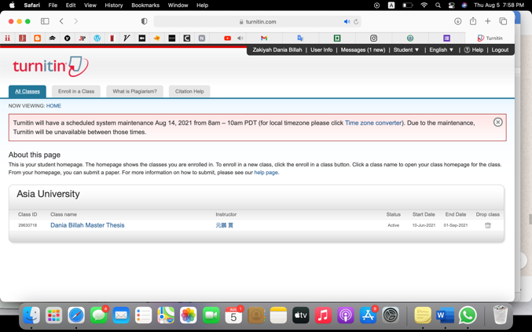

In few minutes, you’ll get the result. Please click “view”

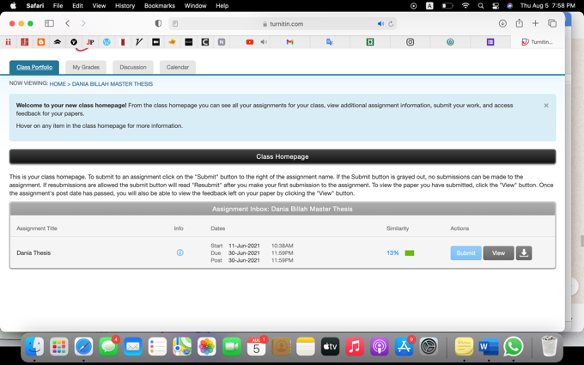

Click the “current view”

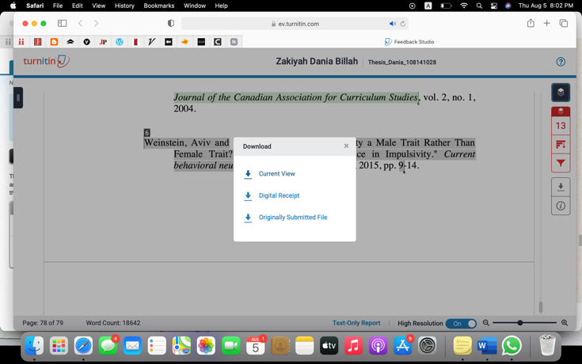

Scroll down the downloaded file, and you’ll find the percentage like this. You need to hand this together with other forms and abstract.
